GMI German-Malaysian Institute

DIPLOMA PROGRAMME
            - PRACTICAL TEST 1
Academic Period : Jan 2026 (Group 1)

Subject | : | SECURING NETWORK
Code | : | CBS 2413
Duration | : | 3 HOURS
Total Marks | : | 40 MARKS

GENERAL INSTRUCTIONS:

- Write down clearly (with capital letters) your name, trade, group and the date of examination at the bottom of this page.
- Do not open this question booklet until you are told to do so by the invigilator.
- Read the specific instructions and questions carefully before answering.

Student’s Name | : | ABDUL HARIZ B. MOHD SARNUDIN
Student’s I/D | : | CBS24070208
Semester/Trade/Group | : | SEMESTER 4 / DCBS / CBS 1
Date | : | 14/4/2026

No | Assessment Criteria | CLO | PO | Level of Diff | Full Marks | Score | Marks | Comment
1 | Configure the basic setting for PC-C, R1, ASA, and DMZ server | 2 | 4 | P3 | 12
2 | Configure routing in between R1 and ASA | 2 | 4 | P3 | 12
3 | Configure SSH | 2 | 4 | P3 | 4
4 | Configure ACL | 2 | 4 | P3 | 8
5 | Screenshot all the configuration for the R1 and ASA | 2 | 4 | P3 | 4
Total |  |  |  |  | 40
Total Marks
Total |  | PO4 |  |  | 40/40
Signature

- Topology
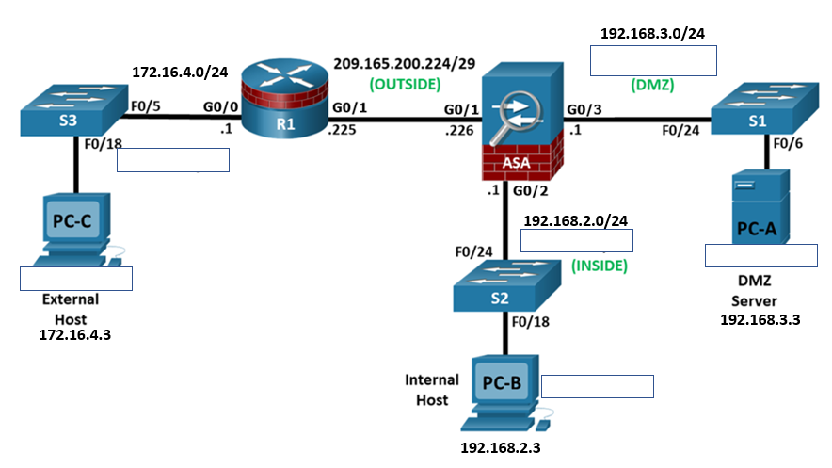
Addressing Table
Device | Interface | IP Address | Subnet Mask | Default Gateway | Switch Port
R1 | G0/0 | 172.16.4.1 | 255.255.255.0 | N/A | S3 F0/5
R1 | G0/1 | 209.165.200.225 | 255.255.255.248 | N/A | ASA G1/1
ASA | G0/1 (OUTSIDE) | 209.165.200.226 | 255.255.255.248 | N/A | R1 G0/0/1
ASA | G0/2 (INSIDE) | 192.168.2.1 | 255.255.255.0 | N/A | S2 F0/24
ASA | G0/3 (DMZ) | 192.168.3.1 | 255.255.255.0 | N/A | S1 F0/24
PC-A | NIC | 192.168.3.3 | 255.255.255.0 | 192.168.3.1 | S1 F0/6
PC-B | NIC | 192.168.2.3 | 255.255.255.0 | 192.168.2.1 | S2 F0/18
PC-C | NIC | 172.16.4.3 | 255.255.255.0 | 172.16.4.1 | S3 F0/18

- Learning Objectives
- Configure the basic setting for PC-C, R1, ASA, and DMZ server.
- Configure routing in between R1 and ASA.
- Configure SSH
- Configure ACL
- Use your name as the router and ASA prompt
e.g R1_Hafiz
e.g ciscoasa_Hafiz

Question 1:
Configure the basic setting for PC-C, R1, ASA, and DMZ server and verify connectivity. Use your name as the router and ASA prompt

Task | Verify connectivity | Result  (screenshot) | Marks
ping from R1 to 172.16.4.3 – should be successful | Succesful | 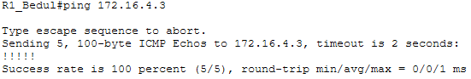 | 2
Ping from R1 to 209.165.200.226 – should be failed | Failed | 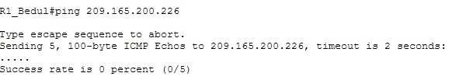 | 2
ping from PC-C to 209.165.200.225 – should be successful | Succesful | 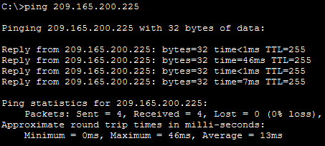 | 2
ping from PC-C to 209.165.200.226 – should be failed | Failed | 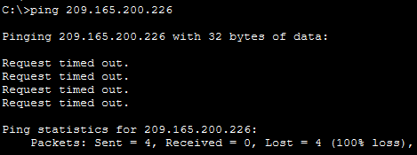 | 2
Ping from PC-C to 192.168.3.3 – should be failed | Failed | 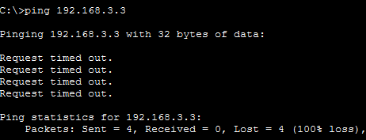 | 2
Ping from PC-C to 192.168.2.3 – should be failed | Failed | 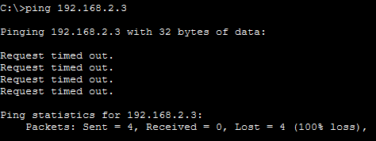 | 2

Question 2:
Configure routing in between R1 and ASA and verify connectivity.

Task | Verify connectivity | Result  (screenshot) | Marks
ping from R1 to 172.16.4.3 – should be successful | Succesful | 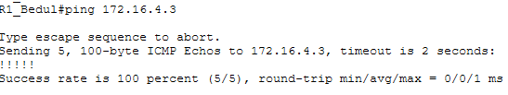 | 2
Ping from R1 to 209.165.200.226 – should be successful | Succesful | 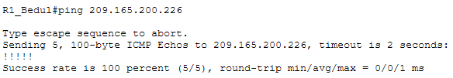 | 2
ping from PC-C to 209.165.200.225 – should be successful | Succesful | 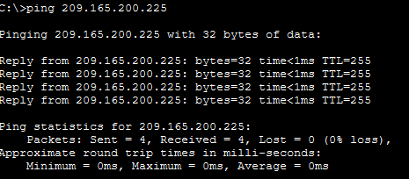 | 2
ping from PC-C to 209.165.200.226 – should be successful | Succesful | 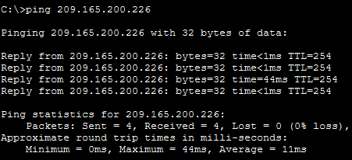 | 2
Ping from PC-C to 192.168.3.3 – should be failed | Failed | 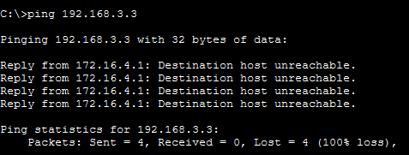 | 2
Ping from PC-C to 192.168.2.3 – should be failed | Failed | 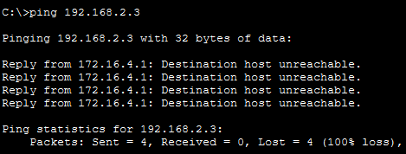 | 2

Question 3:
Configure SSH at ASA and remote access to the ASA

Task | Verify SSH connection | Result  (screenshot) | Marks
Access SSH session from PC-C to the ASA (209.165.200.226) – should be successful. | Successful | 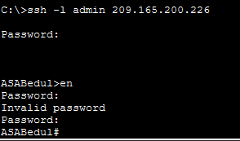 | 4

Question 4:
Configure an ACL at ASA and test access to the DMZ server

Task | Verify connectivity | Result  (screenshot) | Marks
Deny rules:  From a web browser on PC-C, navigate to the DMZ server by using https://192.168.3.3 – should be failed | Failed | 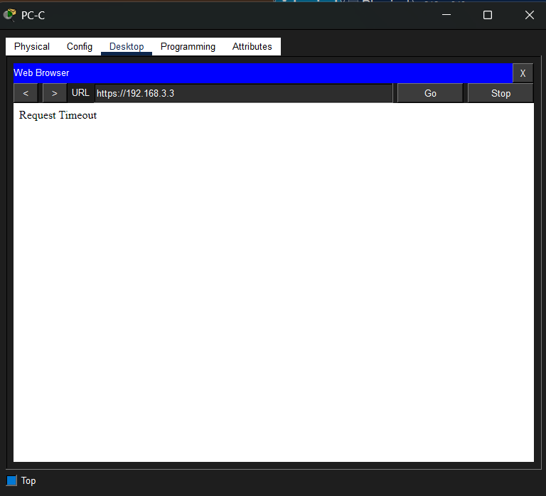 | 2
Deny rules:  From a command line (cmd) on PC-C, ping to 192.168.3.3 – should be failed | Failed | 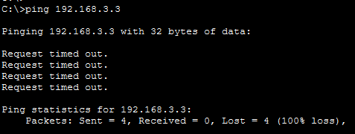 | 2
Idle rules:  From a web browser on PC-C, navigate to the DMZ server by using https://192.168.3.3 – should be successful  But:  From PC-C ping to 192.168.3.3 – should be failed. | Successfu  &  Failedl | 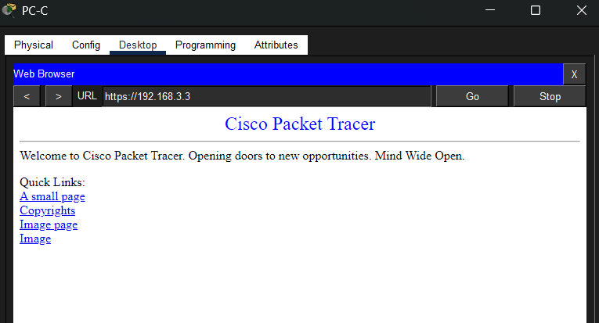  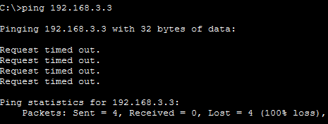 | 4

Question 5:
Screen shot all the configuration for the R1 and ASA.

R1 | 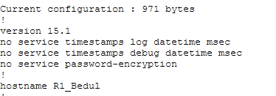  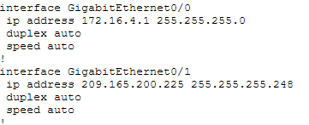  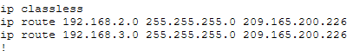 | 2 mark
ASA | 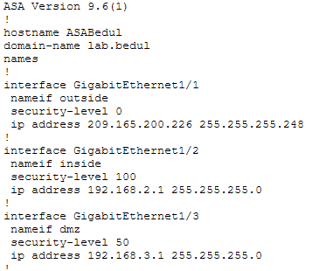  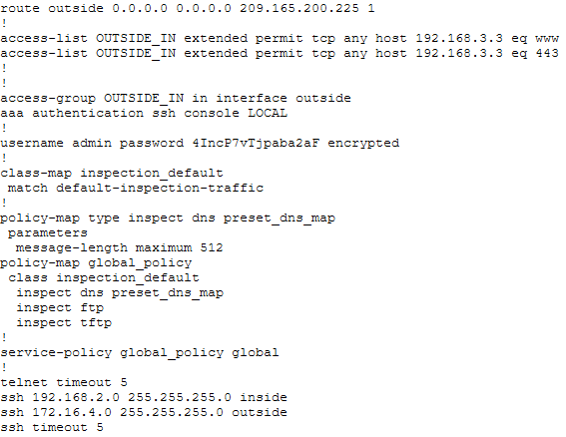 | 2 mark
Sir Hafiz Hensem

